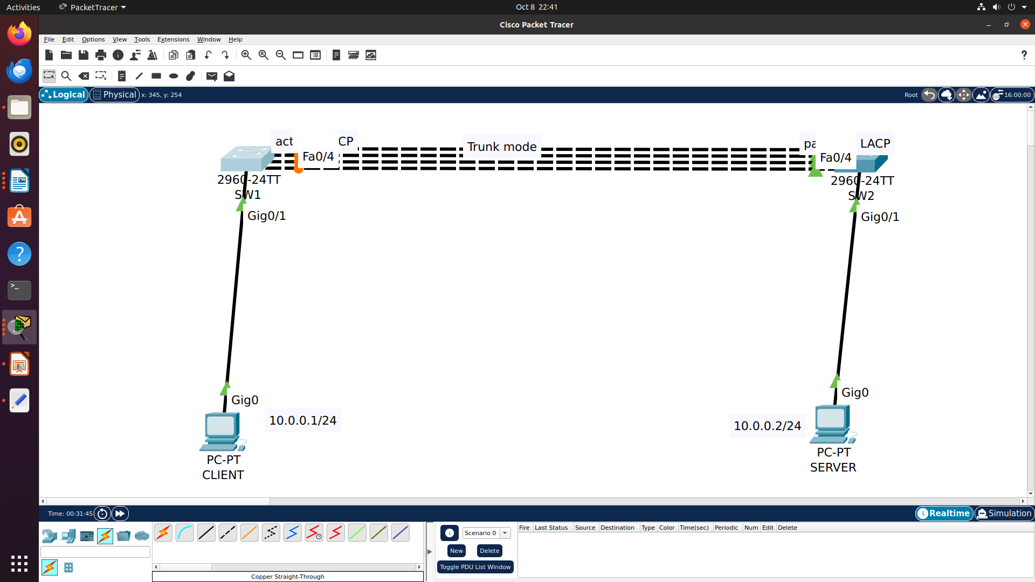

Etherchannel (LACP)

SW1(config)#interface range fastEthernet 0/1-4
SW1(config-if-range)#switchport mode trunk

SW1(config-if-range)#channel-group 1 mode active

SW2(config)#interface range fastEthernet 0/1-4
SW2(config-if-range)#switchport mode trunk

SW2(config-if-range)#channel-group 1 mode passive

SW1#sh etherchannel summary

